**Chapter 24 – UPDATE ON MAE’S & KEN’S PARENTS & SIBLINGS - 1971**

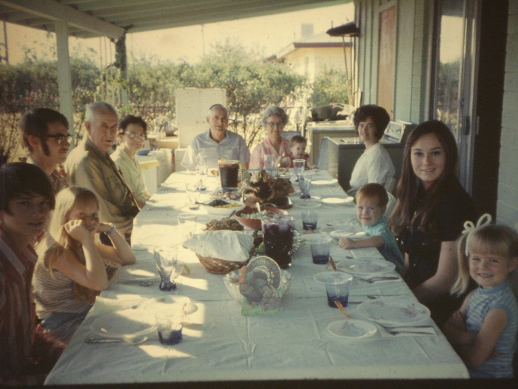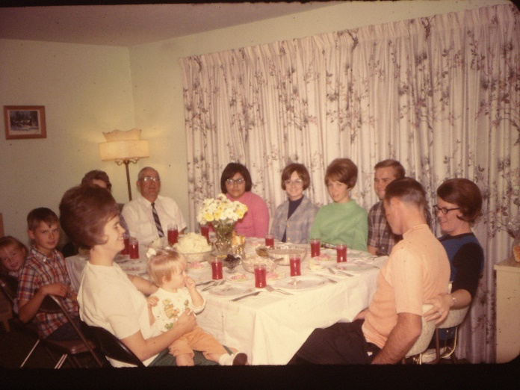

**Family dinner at our home in Ogden** **Family dinner on our patio in Arizona**

**Mom & Dad** moved from their little home in Sunset to a nice new home in Clearfield in Feb. 1970. They are enjoying it there. Mom was very reluctant to move as she loved her little home in Sunset, being near the church, highway, her friends, etc. They had lived there for 28 years. Mom was a “Horter”, so when we were helping them move, Hal took a truck full of stuff to the dumps. Mom found out and was so angry at Hal. Ken & Hal also took a load of old magazines, papers, etc., to their new home. Ken finished the basement for them and he put those magazines in the rafters before he put the ceiling tile up. Mom asked him where her magazines were and he told her that he brought them there, so they must be there somewhere. Mom soon adjusted and made good friends. One of the reasons dad bought mom this home was hoping she would be a better housekeeper now that she had a new home, but that didn’t happen. I remember going to their home and Mom was away getting her hair done or with friends. Dad and I would visit and he would say “Mae, let me show you these closets”. They were bulging full. He said, “Your mom can’t throw anything away and we have way too much stuff.” After Georgia married, he told mom he was going to have her room as his room to study and rest in. He had a desk, filing cabinet and Georgia’s bed. He told Mom that she couldn’t put anything in it as it was his room, but eventually she put stuff in their too, so he showed me that too. I didn’t blame dad, he liked a clean, uncluttered home. **Later in life, he told me “Well, I can’t change your mom, but she has so many other wonderful qualities, so I just have to overlook this one.”**

**Hal and Jean** love their little girl, Cindy. She is now 3 years old.

**Bryce married Deanna** on the 5th of September 1970. They are expecting their first baby in October.

**Terry** is 22 years old, living with the folks and going to Weber College. He went on a mission to Germany.

**Georgia** is almost 20 (September 7th) She’s living with the folks, going to Weber college, has a part-time job, dates a lot, but is waiting for Max Blair who is on a mission.

**Kim** is almost 15. He is a real nice kid. Enjoys his Priesthood activities, was on an Olympic Seminary Bowl and did very well.